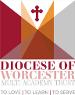

Malvern Parish CE Primary School
‘Learning Together for an Exciting Future’

At Malvern Parish our vision is for all children and adults to become aware of their God given gifts so they can flourish as individuals, achieve academically and build firm foundations for the future. This vision is deeply rooted in strong Christian tradition and based upon:
“I come that they may have life and have it to the full”. John 10.10
“For I know the plans I have for you,” declares the LORD, “plans to prosper you and not to harm you,
plans to give you hope and a future.” Jeremiah 29.11
We seek to develop our vision through our Christian values of Friendship Respect, Trust, Peace, Truthfulness and Forgiveness and live out these values in every part of school life.
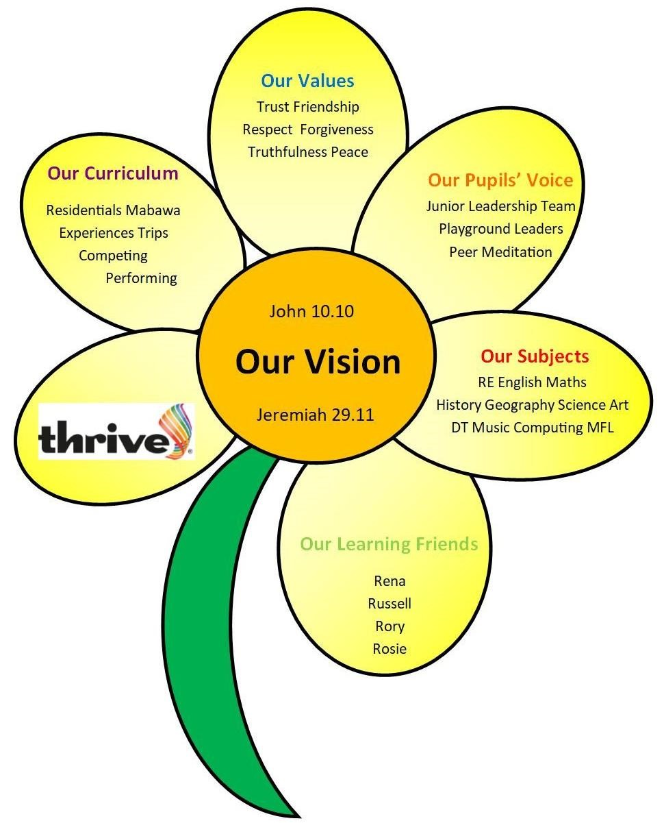
Intent
At Malvern Parish Primary school, we acknowledge the importance of PSHE in aspects of everyday life. We want to provide our pupils with skills that empower them so that they can live their best life and make the most of every opportunity. The PSHE (RSE) curriculum is designed in line with the National Curriculum so that it is accessible to all and supports every pupil’s personal, emotional, social and mental well-being. This in turn helps them to flourish and achieve their potential as well as to lead physically and emotionally balanced lifestyles. It is important that our PSHE learners understand what it means to be a global citizen living in the wider world. We strive to give children a diverse range of experiences to allow them to appreciate and value different people, families and cultures. PSHE (RSE) by nature explores children's feelings, relationships and understanding of how important it is to become a responsible, active member of society.
The Intent of our curriculum is to create learners who are empathetic and effective communicators. We do this through carefully planning and teaching quality lessons which allow children the opportunity to work collaboratively, value the benefits of a healthy lifestyle and promote wellbeing for all ages. Most importantly we want children to appreciate our world and work towards it being inclusive, safe, resilient and sustainable.
Implementation
Our PSHE and RSE (which is covered through the taught curriculum and our wider provision) includes teaching and learning within the following strands and themes:
Family and Relationships
Health and wellbeing
Safety and the changing body
Economic Wellbeing
Citizenship
In order to address the ‘active learning triangle’ of knowledge, skills and attitudes, a wide range of methodology is used in teaching the PSHE curriculum. The focus is on interactive learning, and approaches include: Circle Time, whole class discussion, social skills games and activities, working in pairs/groups, brainstorming, drama and role play, use of puppets, use of story and picture books and use of technology.
Many of these approaches also act as distancing techniques, enabling children to discuss issues without discussing personal experience.
Impact
Our PSHE curriculum will be assessed termly using teacher assessment over time. Termly monitoring will take place and this will include monitoring books, talking to children about their learning and learning walks. A collation of topic assessments can then be reviewed by the subject leader to ensure children are keeping up with the curriculum.
As a result of our approach to teaching PSHE:
- Children enjoy and are enthusiastic about PSHE in our school.
- Are developing skills to be ready for the future.
- Children will flourish and grow.
- Children are empathetic and effective communicators.
- Children are responsible and active members of the school community.

