

Our Approach to teaching Computing at Malvern Parish C of E Primary School.

‘Learning Together for an Exciting Future’
At Malvern Parish our vision is for all children and adults to become aware of their God given gifts so they can flourish as individuals, achieve academically and build firm foundations for the future.
This vision is deeply rooted in strong Christian tradition and based upon:
“I come that they may have life and have it to the full”. John 10.10
“For I know the plans I have for you,” declares the LORD, “plans to prosper you and not to harm you,
plans to give you hope and a future.” Jeremiah 29.11

We seek to develop our vision through our Christian values of Friendship Respect, Trust, Peace, Truthfulness and Forgiveness and live out these values in every part of school life.
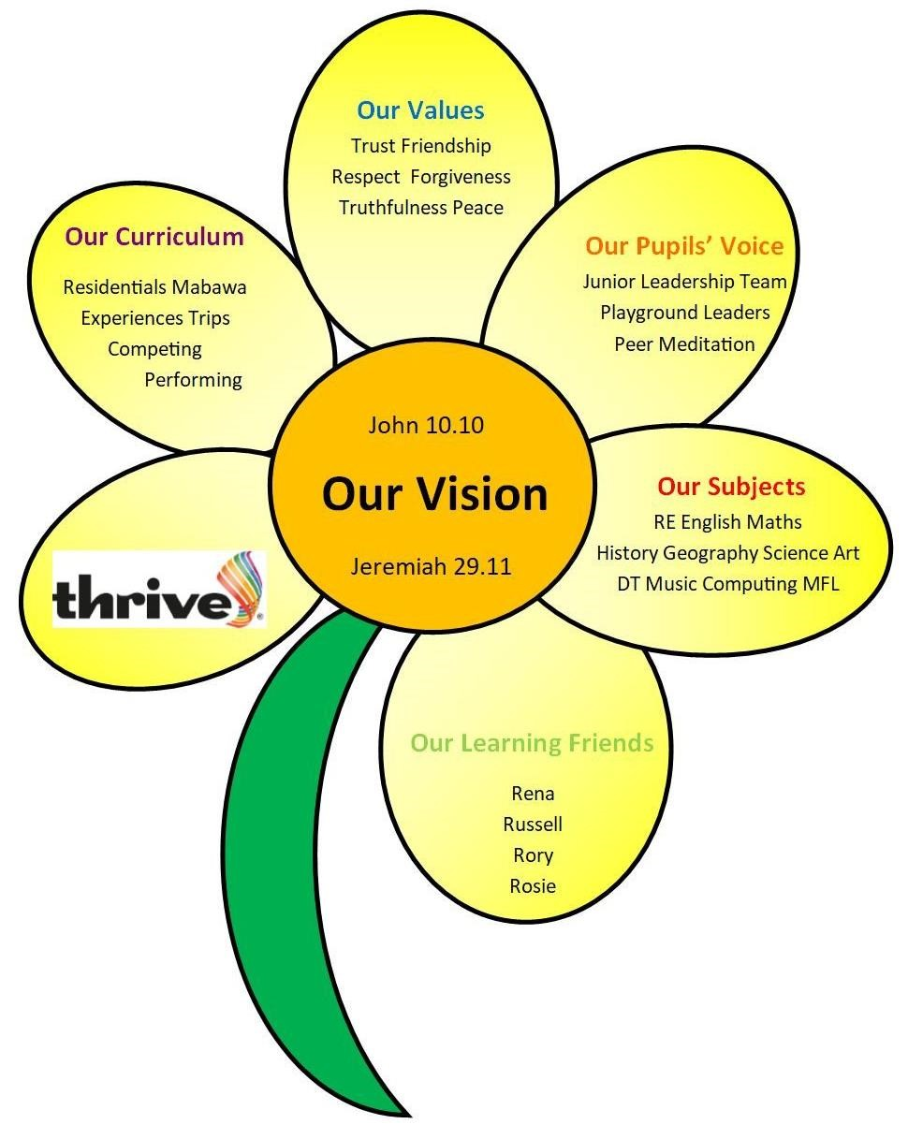

Intent

All pupils at Malvern Parish have the right to have broad, rich and deep learning experiences that balance all the aspects of computing. With technology playing such a significant role in society today, we believe Computing is a skill that children must be taught if they are to be able to participate effectively and safely in this digital world. Computing has deep links with mathematics, science, and design and technology, and is linked to Topic lessons where appropriate. At Malvern Parish, our Computing curriculum provides opportunities for our children to discover their strengths and skills within technology. The core of our computing curriculum is Computer Science, Digital Literacy and Information Technology (IT). We aim for our children to become digitally literate – able to use, and express themselves and develop their ideas through, information and communication technology – at a level suitable for the future workplace and as active participants in a digital world.

We teach a curriculum that enables children to become effective users of technology who can:
- Understand and apply the essential principles and concepts of Computer Science, including logic, algorithms and data representation;
- Analyse problems in computational term, and have repeated practical experience of writing computer programs in order to solve such problems;
- Evaluate and apply information technology analytically to solve problems;
- Communicate ideas well by utilising appliances and devices throughout all areas of the curriculum.
- Stay safe online

Internet Safety
Malvern Parish Primary School takes internet safety extremely seriously. We have an E- Safety Policy that provides guidance for teachers and children about how to use the internet safely. Every year classes participates in lessons on e-safety and children understand how to stay safe when using technology.
You may find the following links useful to help your child stay safe online at home:
Understanding social networking sites and how to keep your children  safe. | Common sense media
Great advice to help keep your children safe online. | Think U Know
Safety information for the whole family. | Microsoft Protect
Report any illegal content on the internet. | Internet Watch
Keep up to date with any e-safety issues. | ChildNet
Safety information for parents. | Safer Internet
Information on gaming safely with resources for parents and children. | Get Game Smart
Understand and share the world of social networking websites with your children. | Make it Secure

Implementation
Teachers plan their curriculum. As part of this planning process, teachers need to plan the following:

- A knowledge organiser which outlines knowledge (including vocabulary) all children must master;
- A cycle of lessons for each subject, which carefully plans for progression and depth;
- A low stakes quiz which is tested regularly to support learners’ ability to block learning and increase space in the working memory;
- Challenge questions for pupils to apply their learning in a philosophical/open manner;
- Trips and visiting experts who will enhance the learning experience;

Impact
Our Computing curriculum is high quality, well thought out and is planned to demonstrate progression. If children are keeping up with the curriculum, they are deemed to be making good or better progress. In addition, we measure the impact of our curriculum through the following methods:
- A reflection on standards achieved against the planned outcomes
- Children can understand and apply the fundamental principles and concepts of computer science, including abstraction, logic, algorithms and data representation;
- Children can analyse problems in computational terms, and have repeated practical experience of writing computer programs in order to solve such problems;
- Children can evaluate and apply information technology, including new or unfamiliar technologies, analytically to solve problems;
- Children are responsible, competent, confident and creative users of information and communication technology.
- A celebration of learning for each term which demonstrates progression across the school;
- Tracking of gains in each quiz;
- Pupil discussions about their learning;

Grace Hart
2022

